Proposal

Modeling Product Success in the Online Beauty Market: A Multi-Method Analysis of Amazon All Beauty Reviews

Jack Owen, Marina Prikis, Meiyi Song, Nini Zhan
APAN 5202: Applied Machine Learning II
Dr. David Shilane
August 12, 2026
Despite the rapid growth of the online beauty market, relatively little is understood about what review-based signals determine whether a beauty product will succeed or fade on a major e-commerce platform. With consumers increasingly relying on peer reviews and platform recommendations to guide purchasing decisions, understanding the relationship between customer feedback, product characteristics, and long-term marketplace performance has become a critical question for both sellers and consumers alike.
This study examines the Amazon All Beauty dataset compiled by McAuley Lab at UC San Diego (Hou et al., 2024), which is well-suited for a multi-faceted analysis of consumer behavior in the beauty industry. Our main research question asks: how do consumer feedback patterns, expressed preferences, and review-based behaviors shape product trajectories in the online beauty market over time? To address this comprehensively, we examine five interrelated sub-questions corresponding to distinct analytical modules. First, we ask whether star ratings alone accurately capture customer satisfaction, or whether NLP sentiment analysis of review text reveals hidden dissatisfaction patterns that ratings fail to reflect. Second, we investigate whether beauty products cluster into distinct market profiles based on price tier and customer response patterns. Third, we examine how consumer satisfaction and review activity shifted between 2015 and 2023, using the full 2000–2023 record only to establish the analysis cutoff. Fourth, because direct co-purchase data are unavailable, we examine which products are reviewed by the same users and whether these co-engagement patterns provide useful association signals. Finally, we ask whether a hybrid recommendation model combining collaborative filtering and review sentiment can outperform a rating-only baseline in predicting individual product preferences.
Literature Review
Current research on online consumer feedback demonstrates that early reviews disproportionately shape a product's long-term trajectory on e-commerce platforms. Bai, Zhao, He, Nie, and Wen (2018) show how early reviewers for effective product marketing on e-commerce websites tend to attribute higher average ratings and post more helpful reviews. Thus, the effect is compounded by consumer attention being limited: Du, Rong, Michalska, Wang, and Zhang (2019) found that users tend to focus specifically on the first few reviews regardless of their helpfulness.
Here, a parallel group of research examines how review helpfulness links feedback to purchasing outcomes. Saumya, Roy, and Singh (2023) reviewed 132 studies and identified textual content, reviewer-related factors, non-textual content, and product-related factors as primary markers of helpfulness. Li, Li, and Kim (2023) showed that consistency between review text and star ratings improves helpfulness prediction, while Nayeem and Rafiei (2023) articulate how reviewer expertise and review timing (particularly for cold-start reviews) are notable yet understudied markers.
Despite this growing literature, most of these studies isolate either early-reviewer or review helpfulness behavior rather than considering timing, sentiment, and purchasing behavior in a unified way, and very few of them focus specifically on beauty products. Our study addresses this gap by examining how early feedback, expressed preferences, and purchasing behavior in tandem shape product success within the Amazon All Beauty dataset.
Data
The dataset is publicly available through the McAuley Lab at UC San Diego and can be accessed through the Amazon Reviews 2023 website and Hugging Face (McAuley Lab, 2023). No special registration is required to access the published dataset. The dataset has two files: a review table and a product metadata table, both linked by a shared product identifier. The review table has 701,528 records from November 2000 to September 2023. Each record contains a star rating, review text, timestamp, helpfulness votes, and a verified purchase flag. The metadata table has 112,590 product entries, including product title, price, store name, and product descriptions. Together, the files contain both structured fields, such as star ratings, verified purchase flags, and timestamps, and unstructured review text, enabling NLP, time-series, clustering, association-rule, and recommendation analyses within a single dataset (Hou et al., 2024).
The review table contained 7,276 duplicate user–product pairs, which were removed by retaining only the most recent review for each pair within the 2015+ analysis window. We also converted Unix timestamps into readable date formats and engineered additional features, including review character length, word count, and a Boolean indicator identifying whether a review contained meaningful text. Price information was missing for 84.3% of metadata records. Further investigation showed that products without price information generally received fewer reviews and slightly lower average ratings, suggesting that the missing price values were not random. Excluding these products would therefore bias the dataset toward more popular and higher-rated items. To preserve the representativeness of the data, we retained all matched reviews regardless of whether price was available and created two analytical datasets: first, a full dataset containing 659,564 reviews for sentiment, time-series, association-rule, and recommendation analyses, and second, a price-filtered subset containing 174,657 reviews for analyses involving price. For clustering, the price-filtered subset was further restricted to 5,996 products with observed prices and at least five reviews. Table 1 below summarizes the key review, derived-text, and product metadata variables used in the analyses.
Methodology
Our project draws on five analytical techniques, each suited to a different piece of the research question: whether consumer feedback and review-based behavior can explain why beauty products succeed or fade. Here, no single method could answer that on its own, so the team split the question into text, structure, time, co-engagement, and personalization, and matched a technique to each. Figure 1 describes how the two working datasets feed each module and how the modules come back together in the discussion. All five analytical modules were implemented in Python. Pandas and NumPy were used for data cleaning, feature engineering, aggregation, and numerical operations. NLTK’s SentimentIntensityAnalyzer was used to calculate VADER sentiment scores. Scikit-learn supported feature standardization, K-means clustering, principal component analysis, and cluster-evaluation metrics, while statsmodels was used for stationarity testing and ARIMA forecasting. Co-review product pairs were constructed using Python’s combination and data-grouping tools, and the recommendation system used a custom NumPy-based matrix factorization model trained with stochastic gradient descent. Matplotlib was used to create the visualizations.
The sentiment-analysis module uses VADER (Hutto & Gilbert, 2014) to score the cleaned text of every review on a scale from -1 to 1. Ratings are rescaled onto the same range, and the gap between a review’s sentiment and its scaled rating becomes a discrepancy measure. A 4- or 5-star review with negative text sentiment counts as hidden dissatisfaction, a case where the star rating alone would miss real frustration. VADER was chosen over a transformer-based sentiment model mainly for scale and transparency: it is computationally efficient across 659,564 reviews, needs no training data or GPU time, and its lexicon-based scores are easy to audit by hand. The tradeoff is that it can misread sarcasm and mixed statements, so hidden dissatisfaction is treated as a signal worth flagging, not a diagnosis of any one customer’s experience. Because there are no ground-truth sentiment labels for this dataset, evaluation is descriptive: comparing sentiment distributions across rating strata and review stages rather than a held-out accuracy score.
K-means clustering groups products by price and customer response, using the priced subset since price is central to the segmentation. Features are standardized before clustering, an assumption K-means requires since it relies on distance. Candidate solutions from K = 2 through K = 8 were compared using inertia, silhouette, Calinski-Harabasz, and Davies-Bouldin diagnostics. Although K = 3 produced the strongest statistical separation, K = 4 was retained because it isolated a distinct high-engagement, low-verification profile. K-means was picked over hierarchical clustering or a Gaussian mixture model for speed at this scale and because its output, a small number of interpretable, overlapping profiles, is easier to act on than a dendrogram or a soft probability assignment. Principal component analysis was used to visualize the K-means solution rather than to select K.
Time-series analysis compares an ARIMA model against naive and seasonal-naive baselines for both review volume and average rating, evaluated on RMSE. Differencing is applied to address non-stationarity, which ARIMA assumes. The final 12 months are held out for testing, with ARIMA(2,2,3) used for review volume and ARIMA(1,2,1) used for average rating. Baselines matter here because a model only earns its complexity if it beats a naive guess; without that comparison, a good-looking forecast could just be tracking the mean. Review volume and average ratings are also examined separately by product cluster.
Association rules and the recommendation system both compensate for a real gap in the data: the bought_together field is empty for every product, so there is no direct co-purchase signal. Association rules use products reviewed by the same user as a proxy “basket,” restricted to the 1,000 most-reviewed products for tractability, and are evaluated on support, confidence, and lift. The retained rules require a minimum co-occurrence count of 10, confidence of at least 20%, and lift of at least 1.2. These patterns represent co-review engagement rather than confirmed co-purchases.
The recommendation system fits a matrix factorization model using an iterative three-user/five-item interaction core. Matrix factorization was suitable because it can learn latent user preferences from sparse user–product rating data while remaining computationally feasible and directly comparable with the sentiment-enhanced hybrid model. It uses a temporal split in which a user’s most recent review is the test case, the second-most recent is used for validation, and all earlier reviews are used for training. The model then blends in review sentiment to test a hybrid model against a rating-only baseline. Sentiment features are calculated from training data only, preventing validation or test reviews from contributing to their own predictions. The models are evaluated on the warm-start test set using RMSE for rating accuracy and HitRate@10 and NDCG@10 for ranking quality, since a model that predicts ratings well can still fail as a top-10 recommender.
Across all 5 methods, the common thread is choosing techniques that are interpretable and computationally feasible at approximately 660,000-review scale over heavier alternatives, like deep-learning sentiment models or neural recommenders, that would add complexity without a clear payoff for a dataset and timeline of this size. Each method targets a distinct aspect of the research question, which lets the findings speak to sentiment, structure, time, co-engagement, and personalization on their own terms instead of collapsing product success into a single score. Since the dataset does not contain sales or confirmed co-purchase histories, review behavior is treated throughout as a proxy for marketplace engagement rather than direct purchasing behavior.
Results
The analyses produced a consistent central finding: star ratings captured broad satisfaction, but they did not fully represent the text, reliability, engagement, or temporal patterns surrounding product performance. Product performance was evaluated through average satisfaction, review activity over time, customer-response profiles, and recommendation accuracy using the 2015–2023 analysis window.
The natural language processing (NLP) sentiment analysis showed that review text was positive overall, yet a meaningful subset contradicted the accompanying star rating. Among 659,564 reviews, 74.4% had positive VADER sentiment, 14.4% were negative, and 11.1% were neutral. Although 71.0% of reviews carried four or five stars, 17,766 of the 468,429 high-rated reviews (3.8%) contained negative text sentiment. Figure 2 shows this rating–sentiment divergence; negative review text appears even among four- and five-star ratings, which demonstrates that high ratings alone can conceal dissatisfaction. As part of the NLP analysis, the early-versus-later comparison produced a more nuanced result. Median sentiment was nearly unchanged between a product’s first five reviews (0.62; n = 282,291) and its later reviews (0.61; n = 377,273), as shown in Figure 3. However, hidden dissatisfaction increased from 2.36% to 2.94%. Products therefore did not experience a broad decline in textual sentiment as they matured, but rating–text mismatch became slightly more common.
K-means clustering was applied to 5,996 products with observed prices and at least five reviews, using 13 standardized features covering price, ratings, verification, helpfulness, review detail and velocity, sentiment, mismatch, and early sentiment. The diagnostic graphs favored K = 3, which had the highest silhouette score (approximately 0.199) and the lowest Davies–Bouldin score. K = 4 was nevertheless retained for interpretability, despite its lower silhouette score of approximately 0.150, because it isolated a distinct high-engagement, low-verification profile. The PCA map reinforces this caution. The first two principal components explained 45.2% of total variance, and the cluster-colored points overlapped substantially (Figure 5). All five price tiers also appeared within every cluster. Price therefore influenced, but did not determine, segment membership. The retained groups are best interpreted as overlapping customer-response profiles rather than rigid market categories.
The cluster-profile analysis showed that the standardized profiles nevertheless revealed useful contrasts. Quiet Reliable Winners formed the largest segment (n = 2,693), with the highest mean rating (4.54), positive sentiment (0.57), and 96.2% verified purchases. Budget/Polarizing products (n = 2,250) had the lowest rating (3.45) and weaker sentiment (0.32). High-Rating/Sentiment-Mismatch products (n = 785) combined a 4.33 mean rating with weaker sentiment (0.32) and 14.1% hidden dissatisfaction. High-Engagement/Low-Verification products (n = 268) had the highest review velocity (2.55 reviews per month) but only 25.4% verified purchases. The profile chart below shows the standardized dimensions driving these differences.
The descriptive time-series analysis showed that annual review volume increased steadily after 2015, peaked in 2021, and then declined. The sharp decrease in 2023 should be interpreted cautiously because the data end in August 2023 (Figure 7). Average ratings also generally declined over the 2015–2023 analysis window, while monthly seasonality remained limited (about ±500 reviews and ±0.02 rating points). In the ARIMA forecasting analysis, forecast performance was mixed (Figure 8). For review volume, the seasonal-naive baseline performed best (RMSE = 920), followed by the naive model (1,038), while ARIMA had the highest error (1,131). For average rating, ARIMA performed best (RMSE = 0.113), narrowly outperforming the naive baseline (0.119) and the seasonal-naive model (0.144). This shows that ARIMA enhanced rating forecasting but not review-volume forecasting. The cluster-level time-series analysis showed that Quiet Reliable Winners remained near a 4.5 average rating, Budget/Polarizing products retained the lowest ratings and declined after 2021, and the two smaller profiles were more volatile (Figure 9). Review volume rose and then fell across clusters, with the 2023 drop again reflecting the incomplete year.
For the association-rule analysis, because bought_together was empty, association rules measured products reviewed by the same user rather than confirmed purchases. Only 7 rules met the thresholds of at least 20% confidence and 1.2 lift, with lift reaching approximately 1,740; most connected variants within the same product line (Figure 10). These findings apply to the 6.8% of reviewers who reviewed at least 2 products and consequently indicate co-engagement rather than co-purchase. Lastly, the recommendation-system analysis showed that the sentiment-enhanced recommender produced mixed results on 806 active users. It reduced test RMSE from 0.887 to 0.881 (a 0.75% improvement), but decreased HitRate@10 from 2.43% to 1.82% and NDCG@10 from 0.0099 to 0.0092 (Figure 11). Consequently, sentiment improved rating prediction slightly but did not outperform the simpler rating-only model for top-10 ranking.

Discussion
Across the five modules, a consistent pattern emerged: star ratings capture broad satisfaction but omit information that only becomes visible when text, time, engagement, and co-review behavior are examined directly. The NLP analysis found that a measurable share of four- and five-star reviews (3.8%) carried negative sentiment, and this rating-text mismatch grew slightly as products matured (2.36% to 2.94%) even though sentiment itself stayed flat. Clustering surfaced a small but distinct High-Engagement/Low-Verification segment that combined high review velocity with a low verified-purchase share. This pattern warrants further review-integrity investigation, although it cannot by itself establish incentivized or manipulated engagement. Time-series results were more mixed; ARIMA modestly outperformed the baselines for average rating but not for review volume, suggesting satisfaction trends are more forecastable at the aggregate level than raw engagement, which may be influenced by factors not represented in the model. The association-rule and recommendation modules, both built to compensate for the missing bought_together field, told the related story that co-review patterns mostly reproduced expected structure rather than new cross-category demand, and blending sentiment into the recommender improved rating accuracy only marginally while modestly hurting ranking quality.
All five research questions were addressed, though to different degrees. RQ1 (NLP) and RQ2 (clustering) were answered clearly: ratings do mask real information, and products fall into distinguishable, if overlapping, customer-response profiles. RQ3 (time series) was answered partially, since forecast quality depended on which metric was modeled. RQ4 (association rules) and RQ5 (recommendation) were answered with more caveats, limited by the review-as-proxy design and by small, non-representative samples.
Several limitations apply across modules. The 2015+ window improves comparability but excludes 15 years of platform history. Every co-engagement measure relies on reviews standing in for purchases, since no direct transaction data exists. Sample sizes for the more granular analyses (806 recommender users; 6.8% of reviewers for association rules) are small relative to the full dataset, and VADER’s lexicon-based scoring can misread sarcasm or mixed sentiment.
Conclusion
These findings point to concrete, low-cost actions. Since a measurable share of high-rated reviews conceals dissatisfaction, platforms should treat sentiment-rating divergence as an early-warning signal and route flagged reviews to a lightweight QA process rather than relying on the star average alone (Figures 2 and 3). The High-Engagement/Low-Verification segment warrants closer review-integrity scrutiny given its unusual combination of high review velocity and low verification (Figure 6). The high-lift association pairs, while few, identify potential within-product-line combinations that could be tested as cross-sell opportunities (Figure 10). The hybrid recommender, by contrast, is not yet ready for deployment. Its ranking performance trails the simpler rating-only model, so shipping it now would add complexity without a clear benefit (Figure 11).
More broadly, this project’s expected impact lies in showing that inexpensive, interpretable methods can surface actionable signals without deep-learning infrastructure, which matters for sellers operating at a smaller scale. The clearest opportunities for improvement are in the data itself; obtaining real purchase records would remove the review-as-proxy assumption underlying two of the five modules, and a longer post-2023 window would let the time-series and recommendation results be validated out of sample. Future work could extend sentiment analysis with transformer-based models to catch sarcasm that VADER misses, evaluate the recommender on a larger user base as more interaction history accumulates, and build on the cluster-level time series here, since Budget/Polarizing and Quiet Reliable Winners products already behave differently enough to warrant separate treatment in future satisfaction-monitoring systems.

References
Bai, T., Zhao, W. X., He, Y., Nie, J.-Y., & Wen, J.-R. (2018). Characterizing and predicting early reviewers for effective product marketing on e-commerce websites. IEEE Transactions on Knowledge and Data Engineering, 30(12), 2271–2284. https://doi.org/10.1109/TKDE.2018.2821671
Du, J., Rong, J., Michalska, S., Wang, H., & Zhang, Y. (2019). Feature selection for helpfulness prediction of online product reviews: An empirical study. PLOS ONE, 14(12), e0226902. https://doi.org/10.1371/journal.pone.0226902
Hou, Y., Li, J., He, Z., Yan, A., Chen, X., & McAuley, J. (2024). Bridging language and items for retrieval and recommendation. arXiv. https://doi.org/10.48550/arXiv.2403.03952
Hutto, C. J., & Gilbert, E. (2014). VADER: A parsimonious rule-based model for sentiment analysis of social media text. Proceedings of the International AAAI Conference on Web and Social Media, 8(1), 216–225. https://doi.org/10.1609/icwsm.v8i1.14550
Li, X., Li, Q., & Kim, J. (2023). A review helpfulness modeling mechanism for online e-commerce: Multi-channel CNN end-to-end approach. Applied Artificial Intelligence, 37(1), 2166226. https://doi.org/10.1080/08839514.2023.2166226
McAuley Lab. (2023). Amazon Reviews’23 [Data set]. University of California, San Diego. https://amazon-reviews-2023.github.io/
Nayeem, M. T., & Rafiei, D. (2023). On the role of reviewer expertise in temporal review helpfulness prediction. arXiv. https://arxiv.org/abs/2303.00923
Olatunji, I. E., Li, X., & Lam, W. (2019). Context-aware helpfulness prediction for online product reviews. In Proceedings of the Asia Information Retrieval Societies Conference (pp. 56–65). Springer.
Saumya, S., Roy, P. K., & Singh, J. P. (2023). Review helpfulness prediction on e-commerce websites: A comprehensive survey. Engineering Applications of Artificial Intelligence, 126, 107075. https://doi.org/10.1016/j.engappai.2023.107075
Appendix
Table 1
Key review, derived-text, and product metadata variables used in the analysis.
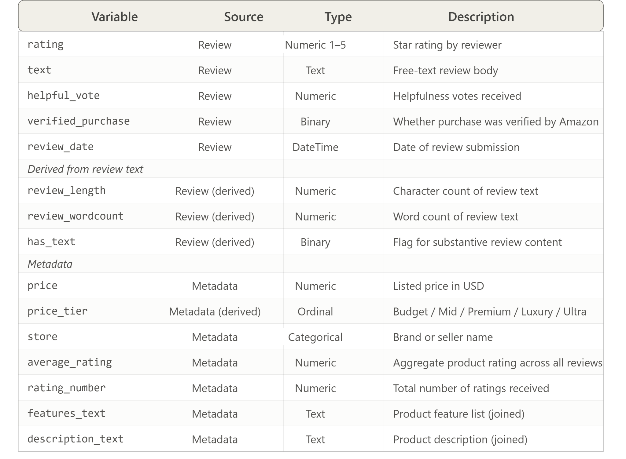
Figure 1
Analytical workflow: Data preparation, the five analytical modules, and how their outputs are synthesized to answer the five research questions.
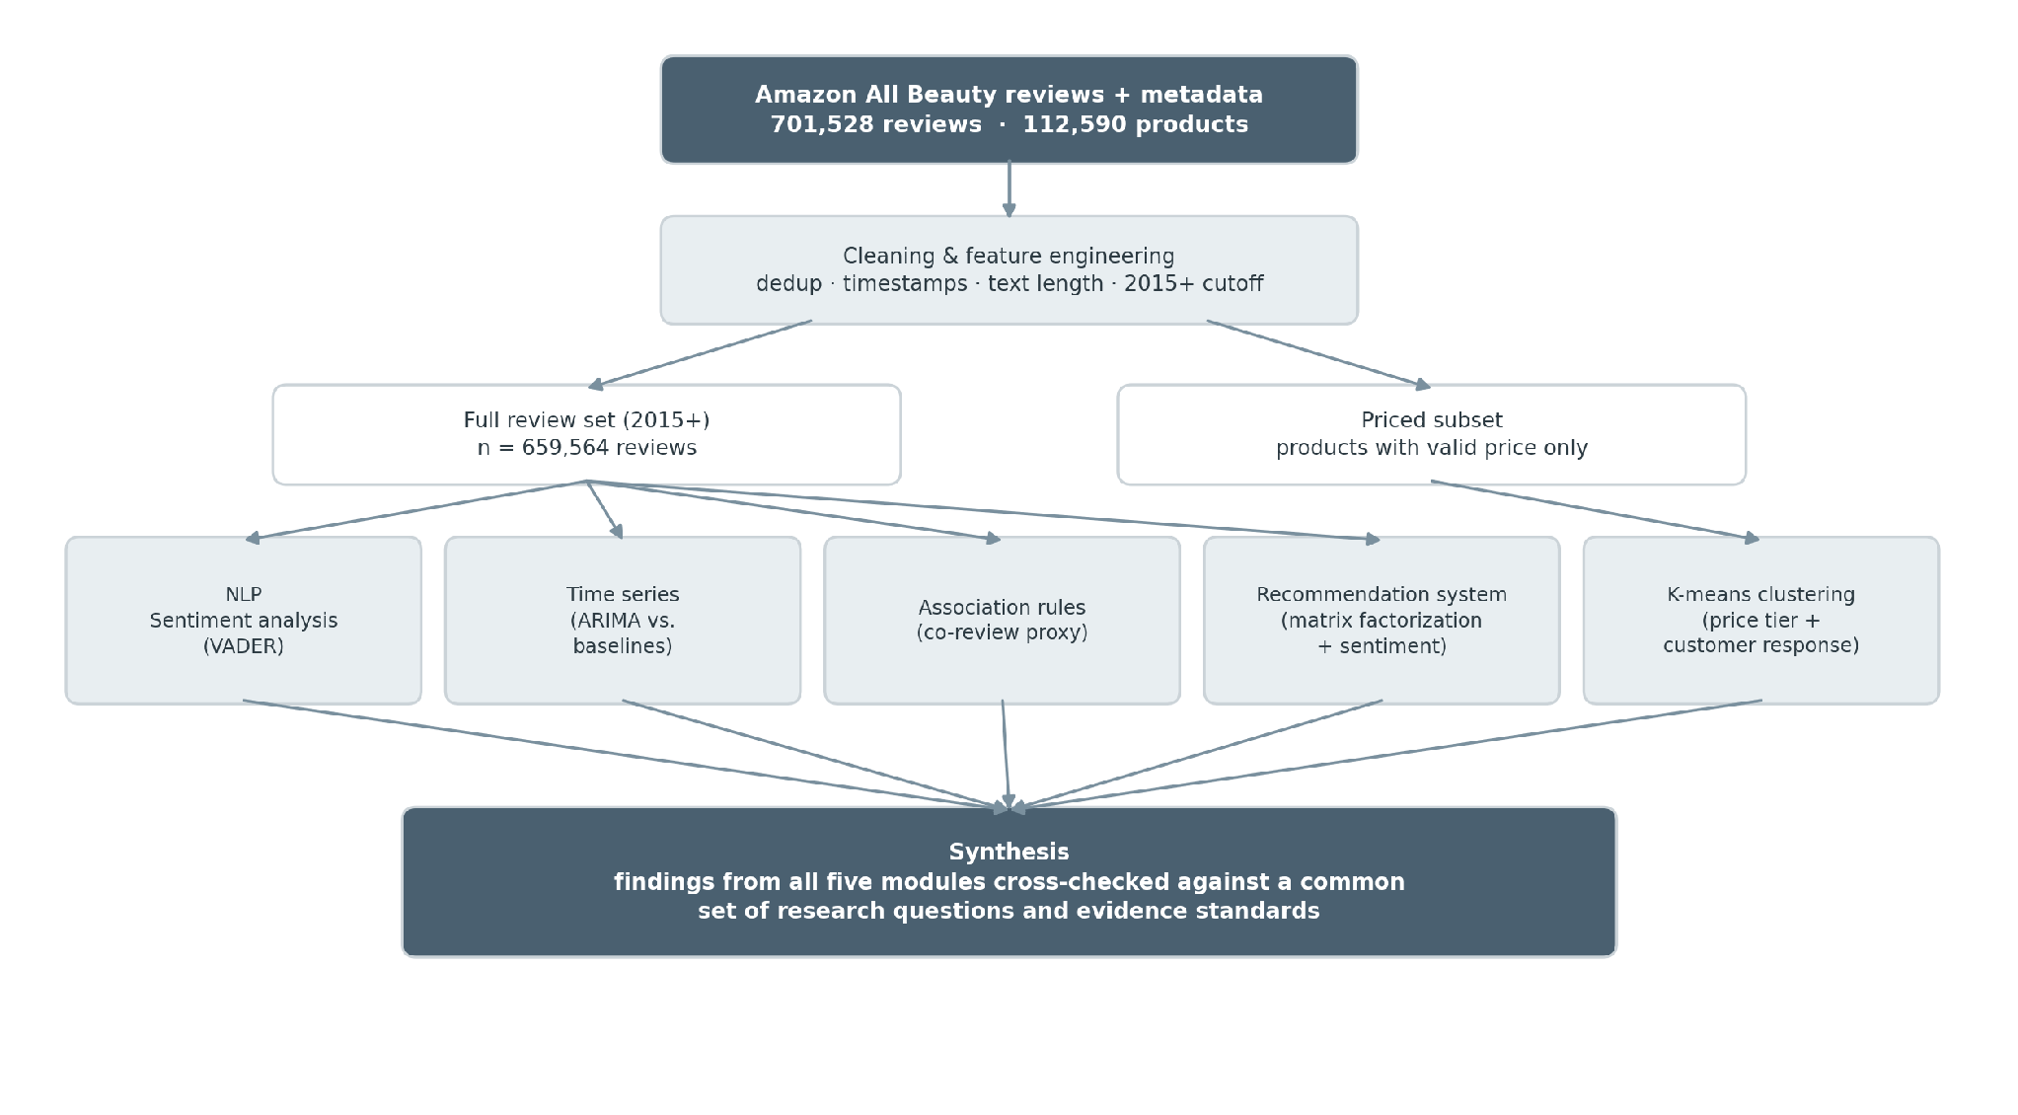
Figure 2
Star rating versus review-text sentiment for a 50,000-review sample (2015+).
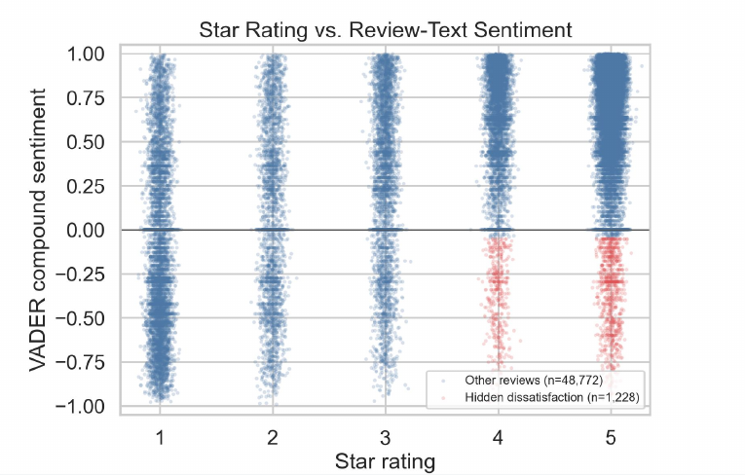
Figure 3
VADER compound sentiment in the first five reviews versus later reviews for each product.
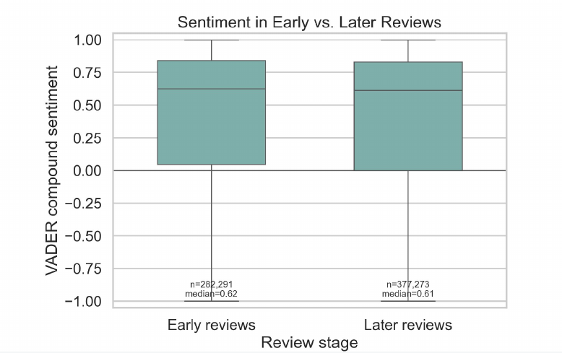
Figure 4
Clustering diagnostics: Elbow, silhouette, and Davies–Bouldin results used to compare candidate values of K.
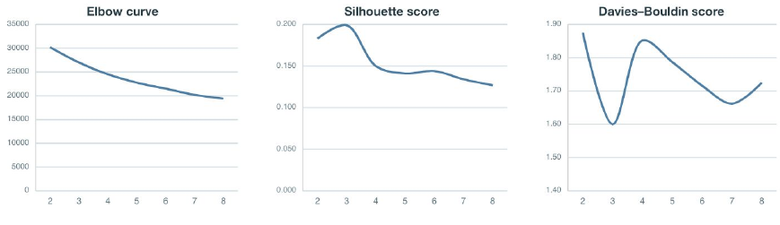
Figure 5
PCA view of products colored by cluster and by price tier (PC1 versus PC2).
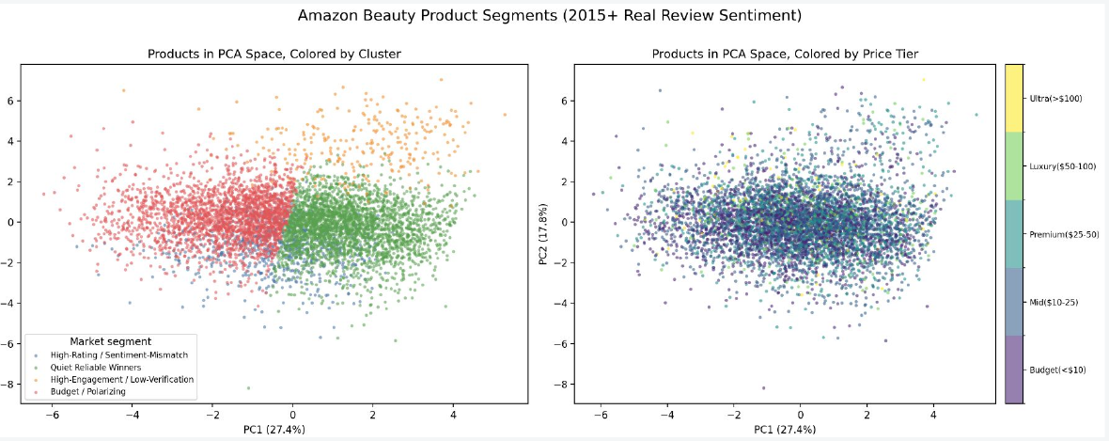
Figure 6
Cluster profile summary: Cell values are cluster means in standard-deviation units (z-scores).
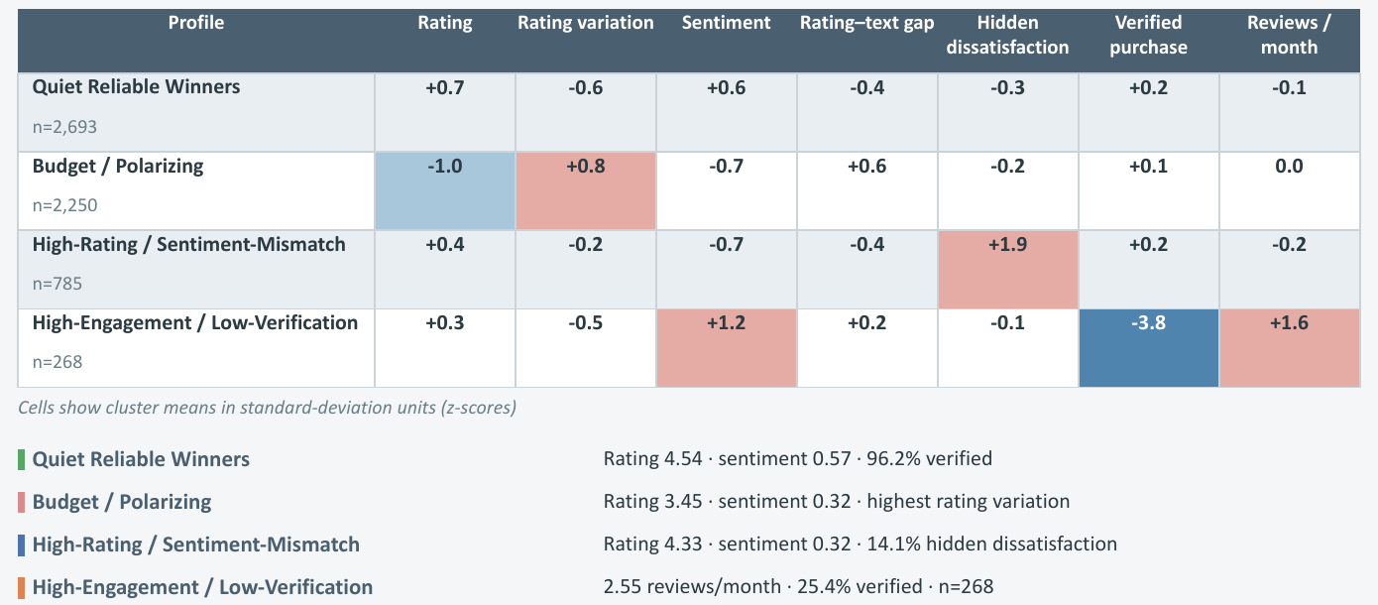
Figure 7
Annual review volume and average rating trends, 2015–2023.
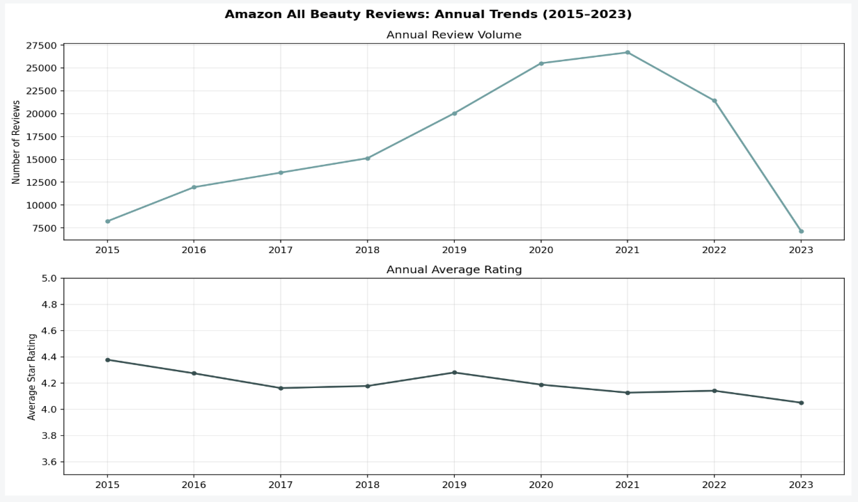
Figure 8
ARIMA forecasts compared with naive and seasonal-naive baselines.
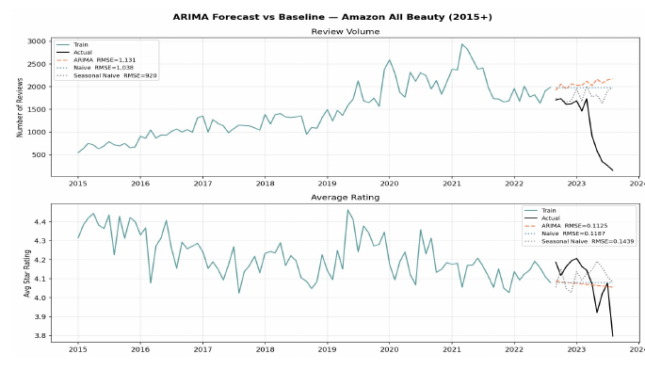
Figure 9
Annual average rating and review volume by product cluster, 2015–2023.
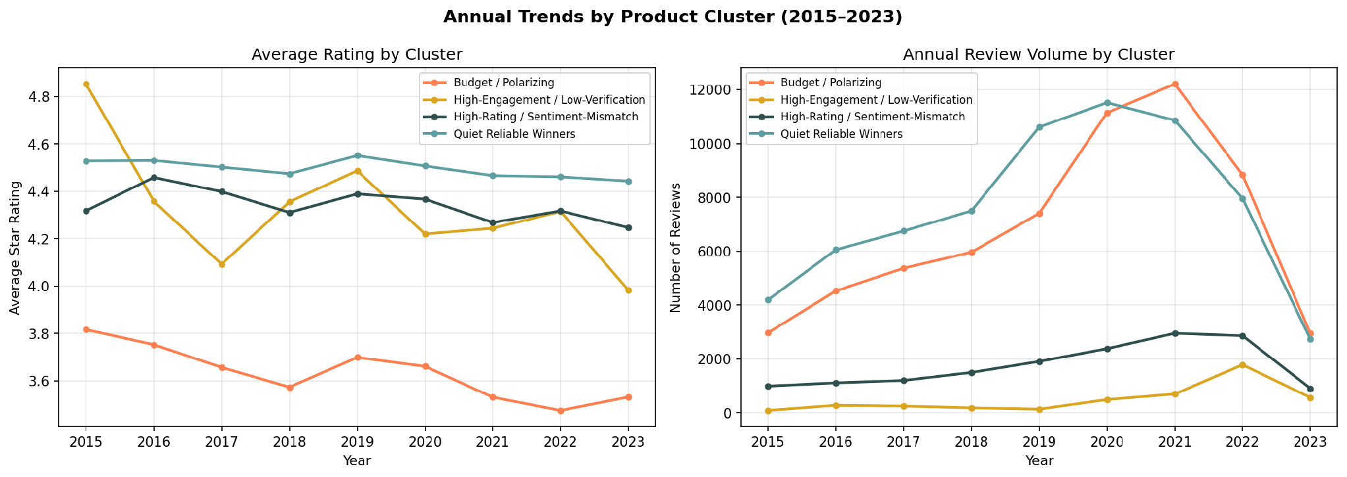
Figure 10
Review co-occurrence rules: Support versus confidence, with color and point size representing lift.
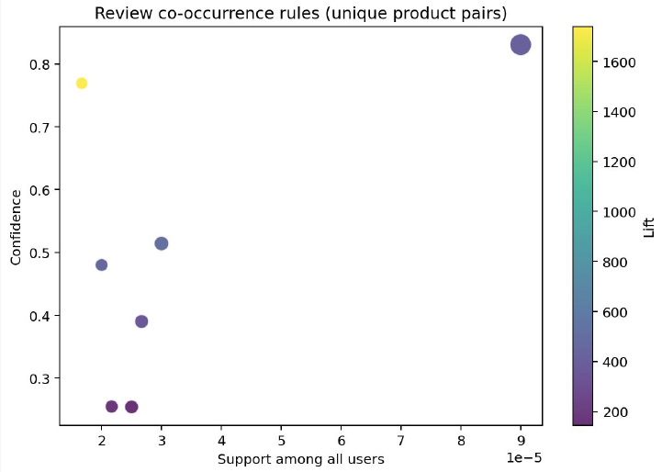
Figure 11
Untouched temporal-test RMSE for all baselines and recommendation models (left) and top-10 ranking performance for the rating-only and hybrid models (right).
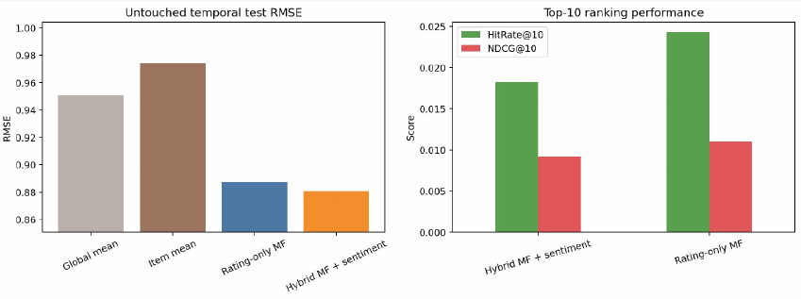

Initial Outline
ML2 Proposal Outline

Proposal Responsibilities (250-300 words each)

- Description of the research problem (Nini)
- Literature discussion (Jack)
- Reach out and find an example of a previous proposal to guide our direction
- Methodology (Marina)
- Description of data (Scarlett)
- Summary of efforts (Scarlett)

- Data collection and cleaning: Scarlett and Marina double-check: Scarlett done with cleaning, Marina double-checked

Our Research Problem:

Despite the rapid growth of the online beauty market, relatively little is understood about what signals determine whether a beauty product will succeed or fade on a major e-commerce platform. This study examines the Amazon All Beauty dataset to investigate how early consumer feedback patterns, expressed preferences, and purchasing behaviors shape product trajectories over time, with the goal of uncovering actionable insights into what drives long-term marketplace success in the beauty industry.

Question (slightly rephrased): How do early consumer feedback patterns, expressed preferences, and purchasing behaviors shape product trajectories over time?

